6. What Makes Port Royal One of America’s Most Exclusive Neighborhoods?

SEO Title
Inside Port Royal: Naples’ Most Exclusive Waterfront Community

Meta Description
Discover why Port Royal is considered one of America’s most prestigious luxury waterfront neighborhoods and what makes it unique.

Target Keywords
Port Royal Naples FL, Port Royal luxury homes, Naples exclusive neighborhoods, Port Royal Club

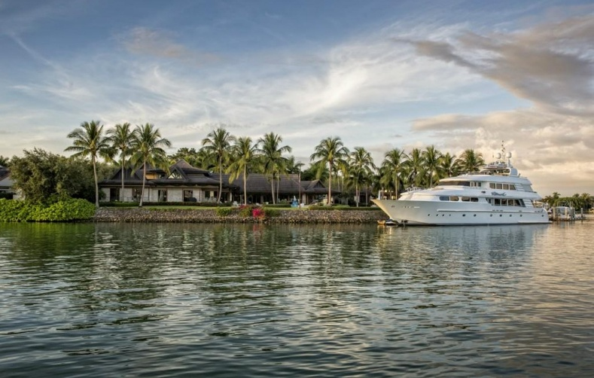

Internal Linking Opportunities
- Port Royal neighborhood guide
- Waterfront listings page
- Naples luxury market reports

Suggested CTA
Explore available homes in Port Royal and learn what makes this iconic neighborhood one of the nation’s premier luxury destinations. Contact Michael Giacalone at Premier Sotheby’s International Realty for private market insights and available listings. 239.431.0321

Inside Naples’ Most Prestigious Waterfront Community
Port Royal has earned a reputation as one of the most prestigious luxury neighborhoods in the United States, and for good reason.
Located along the Gulf of Mexico in Naples, Port Royal offers a level of exclusivity rarely found elsewhere. The community is known for expansive waterfront estates, private beach access, deep-water canals, and exceptional privacy.
Many homes feature private docks capable of accommodating large yachts, allowing residents immediate boating access to the Gulf. This boating lifestyle is a major reason buyers from across the country continue to seek properties in the area.
Beyond the homes themselves, Port Royal offers a unique sense of tranquility. Streets are lined with tropical landscaping, traffic is minimal, and the atmosphere feels secluded despite being only minutes from downtown Naples.
The Port Royal Club further enhances the neighborhood’s appeal. Residents enjoy access to beachfront dining, fitness facilities, tennis, social events, and resort-style amenities that contribute to the area’s strong sense of community.
Another factor driving Port Royal’s desirability is limited inventory. The neighborhood has a finite number of waterfront properties, which helps preserve long-term value and exclusivity.
Luxury buyers are increasingly seeking destinations that offer both privacy and lifestyle, and Port Royal delivers both at the highest level.
For those exploring Naples luxury real estate, Port Royal continues to represent the gold standard of coastal living.

